\

What is the Children's Advoeaey Center?
Incorporated in 1997, the Lake Sumter Children's Advocacy Center ((AC) is

The serviees of the
Children's Advoeaey Center have been made possible by:
•
LAKE SUMTER

.....

(5} @)(0
the culmination of our community's volunteers and agency representatives
working together to provide child abuse
C-lttu.olv-eV\,'.s Advocetc C-el/\kev-

victims with all necessary services in a single location. Based on a successful national model, our CA( is a collaborative effort of local government and community agencies dedicated to the investigation, treatment and
prosecution of child abuse.
The (AC warks in collaboration with: the Lake County Sheriff's Office, the Sumter County Sheriff's Office, various municipal police departments, the State Attorney's Office, the Department of Children & Families, the Guardian Ad Litem program, and other community service agencies.

Our Mission Statement
The mission of the LakeS4mter,Children's Advocacy Center is lo provide a child-friendly, community-based facility where a child victim can be safely interviewed, provided with crisis counseling, receive medical exams and long term specialized therapy, when needed.
The (AC also assists in the coordination of investigations and intervention services by bringing together professionals and agencies as a multidisciplinary team to create a child­ focused approach to child sexual and physical abuse cases.
Our philosophy is in accordance with community directives established by the U.S. Department of
S
Justice for victims' rights and services. Our ·,.;
Center is also a Fully Accredited (AC in ,; : good standing with the National Children's
M : '
Alliance.
SNEf Helping Kids Shine Grant
Florida Department of Health
i
Hans & Cay Jacobson Foundation
Lake County Children's Services Council
Matthew & Mildred Hunter Charitable Foundation National Children's Alliance
Orlando Sentinel
Publix Supermarket Charities Rogers' Foundation
State of Florida
Sumter County Commissio·ners Victims of Crime Act (VOCA)

Private Donations • In-Kind Donations Fundraising Events

.-,n. --:",' 111"!'.'
I\ .
child protection team
Children's Medical Services

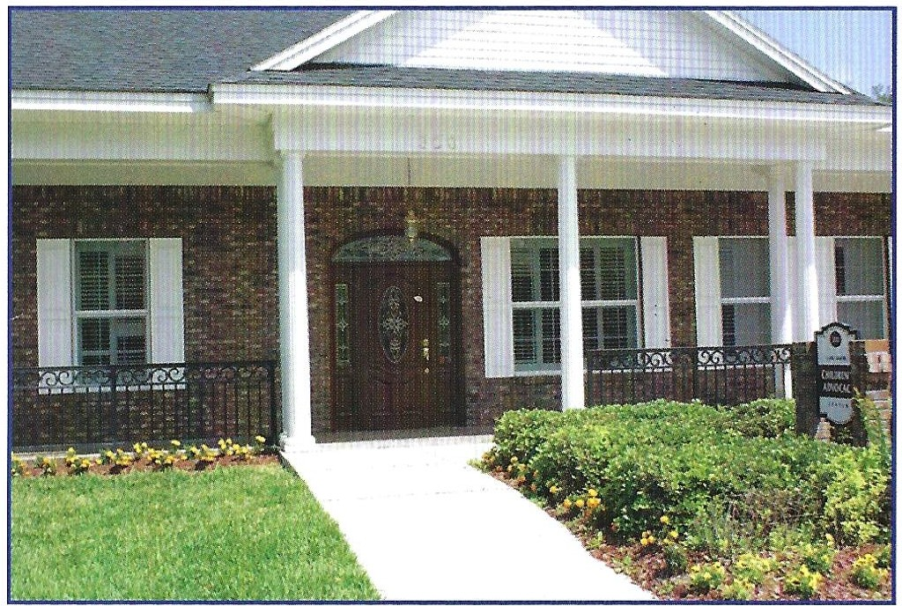
Working With You
to STOP

Child Abuse

300 S. Canal Street
Leesburg, FL 34748
Phone:(352) 323-8303
Fax:(352) 323-1394

eae4ki .or

Can You Help? Progi'aJ.llS & Serviees

/w
1

/w----
1
stop Child Abuse" License Plate _
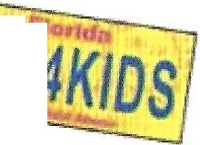When you purchase a "StopChild \I· 11
4K/DS
Abuse" license plate, you help . ,r.' publicize the need to stop child ...t-. - -- abuse while supportingevery CA( \:1' '(t)I'-"•'
in the state of Florido. Jo tnt t:>ri.ve
Our CA( receives o portion of the funds for \' AgAtll\St every licenseplate purchasedin Lake and Cl-tfl.J:) Al!'.IA.56 Sumter Counties.
The "StopChild Abuse" tog costson additional $25, all of whichgoesto child abuse preventionand interventionprogramsin Florido.
Order thistogwhen it's timetorenew! The best wayto purchase the "Stop ChildAbuse" tog istocontact your local tax collector'soffice.Purchaseyour "StopChildAbuse" tognowor at thetimeof yourrenewal.

Our"WISH LIST" includes financial contributions towards our everyday operating costs, sponsors to help with our routine maintenance, funds to provide drinks and snacks to the children we serve and all kinds of craft supplies to be used during therapy sessions.

BOARD OF DIRECTORS
Despite our best efforts, child abuse continues to occur in lake and Sumter Counties. Our CAC provides services to over 1,000 children each year.
The CAC has developed programs in response to community need to protect and educate children al all ages. All
services are provided at no charge to the family. Our service1s include:
Counseling
Our Master's level licensed therapists provide crisis counseling und long term therapy to the child victim. Specialized therapies such as Trauma Focused Cognitive Behavioral Therapy, Play Therupy, Art Therapy and Animal Assisted Therapy are used to help the child deal with the issues regarding the abuse.

Child Abuse Education and Prevention Programs
The staff of the CAC provides trainingto other professionals in thecommunity on the prevention of child abuse, the identification of child abuse and guidelines on how to respond to childdisclosures of abuse. Presentations are also given to schools and community organizations.

Medical Exams
Specially trained medical providers conduct medical exams at our CAC facility. Our CAC maintains state-of-the-artequipment that enables the medical team to observe and document injury. We have one Board Certified Pediatrician and two ARN P's on

PRESIDENT: Dr. Doug Moffett, O8-GYNAssociates of Mid-Florido,PA VICE PRESIDENT: Meredith Kirste, M.MeredithKirste, P.A. SECRETARY: VaneeseCollins, Community Volunteer TREASURER: Alex .OgilvieIll, CommunityVolunteer
staff to provide these specialized exams.

Victim Advocacy
The Victim Advocate is a designated, trained volunteer who provides comprehensive, coordinated victim support and advocacy

Mary Lou Clark CommunityVolunteer
Kayla Dees CommunityVoluntee
Sheriff Bill Farmer Sumter CountySheriff'sOffice
Peggy Fuller Community Volunteer
Sarah Jane Hewitt Hewitt Companies
Stephen May
Chick-Iii-A of The Villages
Sue Purdy CommunityVolunteer
John Rohan VillagesCommunity Development Districts
Jacqueline Summers SummersEnterprises
Paula J. Stinson
. CommunityVolunteer
Katie Stradinger Propertiesof TheVillages

Directors Emeritus Pete Wahl Community Volunteer
Cindy Clark Community Volunteer
Chris Heaton CommunityVolunteer
Jill McDowell Community Volunteer
services to the child and non-offending family members.

Child Protection Team
The Child Protection Team provides Forensic Interviewsm, edicCIIexams, specialized interviews, psycho-social assessments and other services to child victims of abuse and their family members. It also facilitates Multidisciplinary Team Staffings to assure no child "falls through the cracks."

Recorded Forensic Interviews
This interview is conducted by specially trained CAC Forensic Interviewers in our non-threatening, child friendly environment. Video recording of the child's statement reduces trauma by keeping the child from having to repeat the story again and again. The recording is entered as evidence and may prevent the child from having to testify in court.

